How to install anaconda

**If Anaconda is Installed.**

Enter this command on command prompt

“conda -V”

If it shows version of Anaconda, you don’t have to anything.

If conda command not recognized, you need to set PATH for Anaconda.

Set this two PATH to environment variable.

***(Anaconda directory)/Anaconda3/Scripts***

***(Anaconda directory)/Anaconda3***

Ref : <http://ac-stegral.hateblo.jp/entry/2018/04/17/005218>

(Japanese document,sorry)

**If Anaconda is not Installed**

Download installer from here

<https://www.anaconda.com/>

**IMPORTANT**

Check “Add Anaconda to my PATH …”

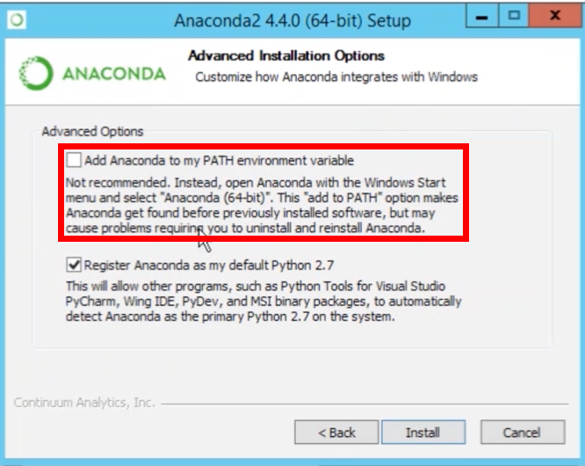

Follow the instruction.